CHINESE NUTRITION

Summary of Privacy Practices

We don't do anything with your health data without your written consent. We have a complete NOTICE OF PRIVACY PRACTICES that is available in our office if you want to read the complete details.

- How we may use and share data about you:
A) Treatment – to give you medical treatment or other types of health services
B) Payment – to bill you or a third party for services provided to you C) Health Care Operations – For our own operations such as quality control, compliance
monitoring, audit, etc

II. Disclosures where we do not have to give you a chance to agree or object:
` A) to you B) As required by state, federal, or local law C) if child abuse or neglect is suspected D) public health risks (for public activities to prevent and control spread of disease) E) lawsuits and disputes (in response to a court or administrative order) F) law enforcement (to help law enforcement officials respond to crimial activities) G) Coroners, medical examiners and funeral directors H) Organ or tissue donation facilities if you are an organ donor I) to avert a threat to an individual or to public health safety

III. Disclosures where we have to give you a chance to agree or object:
A) patient directories – You can decide what health data, if any, you want to be listed in patient directories B) persons involved in your care or payment for your care – We may share your health data with a family member, or a close friend or other person that you have named as being involved with your health care.

- Other uses of health data:
Other uses not covered by the notice or the laws that apply to us will be made only with your written consent.

V. You have the following rights relating to health data we keep about you:
A) Right to inspect your health record and to receive a copy of your health record upon request. B) Right to ammend information in your health record you believe is inaccurate or incomplete C) Right to know to whom we have disclosed your health information D) Right to ask for limits on the health information we give out about you. E) Right to receive communication from us about your health information in alternative ways. F) Right to a paper copy of the complete notice of privacy practices.

I acknowledge that I have read this SUMMARY OF PRIVACY PRACTICES and that I understand that I may request the full NOTICE OF PRIVACY PRACTICE document at any time.

Signature of Patient / Guardian: ________________________________ date: _______________

NEW PATIENT INTAKE FORM

Name: _____________________ DOB: ___________ Gender: __________

Address: ___________________________ City: _____________ State: ______ Zip: __________

Email: ___________________________ Phone1: _______________ Phone 2: ________________

Emergency Contact: _______________________________ Phone: ___________________

Marital Status: ___________________ Height: ____________ Weight: _______________

Primary Care Physician’s Name AND Phone: ___________________________________________

Name of your Health Insurance company (if any): _______________________________________

How did you Hear about us? _____________________________________________________

Reason for Today’s Visit: ____________________________________________________________

Employer’s Name: _________________________________________________________________

Are you Taking Prescription Drugs? Please list: ________________________________________

__________________________________________________________________________________

Are you Taking any Supplements? Please list: __________________________________________

__________________________________________________________________________________

Check any of the following that you currently use:
___ Laxatives  ___ Antibiotics  ___ Sleeping Pills  ___ Anti-Depressants | ___ Pain relievers  ___ Cortisone  ___ Allergy Medications  ___ Hormones | ___ Antacids  ___ Thyroid Medication  ___ Heart / Bloods Meds  ___ Birth Control Pills

Allergies: __________________________________________________________________________________

Family Medical History (please check all that apply to your or your close family):
___ Hepatitis  ___ AIDS  ___ Asthma  ___ Seizures | ___ Alcoholism  ___ Diabetes  ___ Stroke  ___ Drug Addiction | ___ Heart Disease / High blood pressure  ___ Mental Illness  ___ Cancer  ___ Other: _________________________

Do you smoke? How many per day? __________________________________________________
Do you drink? How often? How many per day? ________________________________________

Please Mark any Areas of Pain in the Body below: Symptoms:
____ Muscle cramps
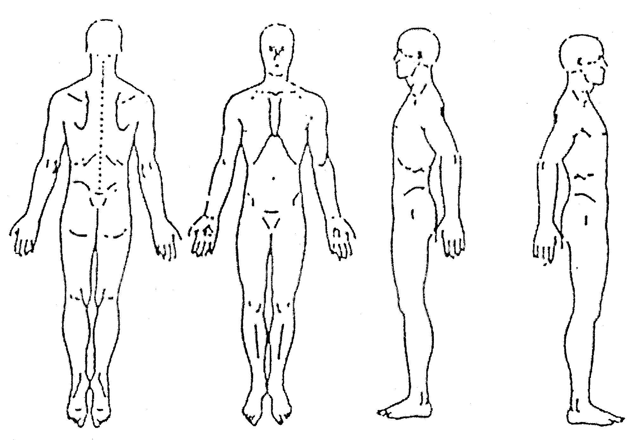
____ Muscle weakness
____ Muscle spasms
____ Muscle atrophy
____ Joint pain
____ Joint instability
____ Falls / falling down
____ Limited range motion
____ Arthritis

____ Sharp pain
____ Dull pain

____ Acute pain (recent)
____ Long term (chronic)

____ Numbness / Tingling
____ Restlessness / RLS
____ Seizures

If you had to pick one, what is your primary emotion within the last 6 months?
_____ Joy _____ Fear ______ Anger/Frustration _____ Grief ______ Worry

How would you rate your energy scale 1 to 10, with 10 being excellent? ______
How would you rate your stress 1 to 10, with 10 being extremely stressed? ______

CURRENT SYMPTOMS:
____ Breathing difficulty ____ Overly emotional ____ Depression
____ Chills or Fever ____ Fatigue ____ Excess thirst
____ Indigestion ____ Night sweating ____ Aversion to drinking water
____ Weight Loss ____ No Sweating ____ Aversion to food
____ Weight Gain ____ Sweating easily

DIGESTION:
____ Nausea ____ Constipation ____ Intestinal Pain
____ Vomiting ____ Diarrhea ____ One bowel movement per day
____ Feeling of Fullness ____ Hiccups ____ Less than 1 bowel movement/ day
____ Bloating ____ Acid Reflux ____ Blood in stool
____ Gas ____ Bad breath ____ Hemorrhoids
____ Feeling of Urgency ____ Poor Appetite ____ Mucus in stool

RESPIRATORY:
____ Difficulty breathing ____ Pleurisy ____ Can’t sleep lying down
____ Chest tightness ____ Asthma / Wheezing ____ Phlegm / Congestion

CARIOVASCULAR:
____ Blood clots ____ Chest Pain ____ Palpitations
____ Edema / Swelling ____ Pacemaker ____ High or Low Blood Pressure

URINARY
____ Painful urination ____ Bed Wetting ____ Frequent UTI ____ Kidney Stone
____ Frequent urination ____ Wake to urinate ____ Bed Wetting

NEUROPHYSIOLOGICAL:
____ Depression ____ Worry easily ____ Easily disturbed by noise
____ Irritability ____ Unresolved Grief ____ Foggy / Cloudy mind
____ Easily stressed ____ Frightened easily ____ Poor Concentration
____ Easily frustrated ____ Poor Memory ____ Nervousness

NEUROCOLOGICAL:
____ Dizziness / vertigo ____ Loss of balance ____ Poor memory / concentration
____ Fainting / Syncope ____ Convulsions ____ Paralysis
____ Drowsiness ____ Tremor ____ Stroke

HEAD, EYES, EARS, NOSE, THROAT:
____ Poor Eye Sight ____ Ear ringing ____ Headaches
____ Blurry Vision ____ Deafness ____ Migraines
____ Night blindness ____ Earaches ____ Concussions
____ Red eyes ____ Hearing Loss ____ Hyper / hypo thyroid
____ Dry / Itchy eyes ____ Dry throat ____ Facial numbness
____ Glaucoma ____ Itchy / Tickle throat ____ Sinus problem
____ Cataracts ____ Sore throat ____ TMJ / lockjaw
____ Spots in vision ____ Swollen lymph nodes ____ Mouth / Lip sores
____ Eye strain ____ Throat drainage ____ Excess Saliva

VITALITY AND IMMUNITY:
____ Frequent colds ____ Slow wound healing ____ Difficulty staying asleep
____ Low energy ____ Slow to wake up ____ Tender / Achy all over
____ Lethargic ____ Insomnia ____ Hard to stop thinking

MEN ONLY:
____ Poor or Excess libido ____ Impotence ____ Premature Ejaculation
____ Infertility ____ Nocturnal Ejaculation

WOMEN ONLY:
____ Could you be pregnant? ____ PMS How long is your cycle? ______
____ Pregnancies: # _____ ____ Painful Menstruation ____ Heavy bleeding
____ Miscarriage: # _____ ____ Vaginal Pain ____ Light bleeding
____ Live births: # _____ ____ Vaginal Itching ____ Clots
____ Birth control pills ____ Vaginal Dryness ____ Prolonged bleeding
____ Menopausal ____ Vaginal Discharge ____ Mastectomy / Lumpectomy

